Module 2-Power Query (Advanced ETL)
Power Query is a data preparation and ETL (Extract, Transform, Load) tool in Microsoft Excel and Power BI. It helps users clean, transform, combine, and load data from multiple sources efficiently.

1. Advanced Transformations
Advanced transformations allow users to clean and reshape data before loading it into Excel or Power BI.
Common Transformations
- Remove duplicates
- Split columns
- Merge columns
- Replace values
- Pivot and Unpivot columns
- Group By operations
- Conditional columns
- Data type conversion
Example Dataset
Employee ID | Name | Department
101 | Amit Kumar | IT
102 | Priya Singh | HR
103 | Raj Sharma | Sales
Example: Split Column
Suppose a column contains:
Full Name
Amit Kumar
Priya Singh
Convert into:
First Name | Last Name
Amit | Kumar
Priya | Singh
Steps
- Select data.
- Go to Data → Get Data → From Table/Range.
- Open Power Query Editor.
- Select the column.
- Click Transform → Split Column.
- Choose delimiter (Space).
- Click OK.
Image
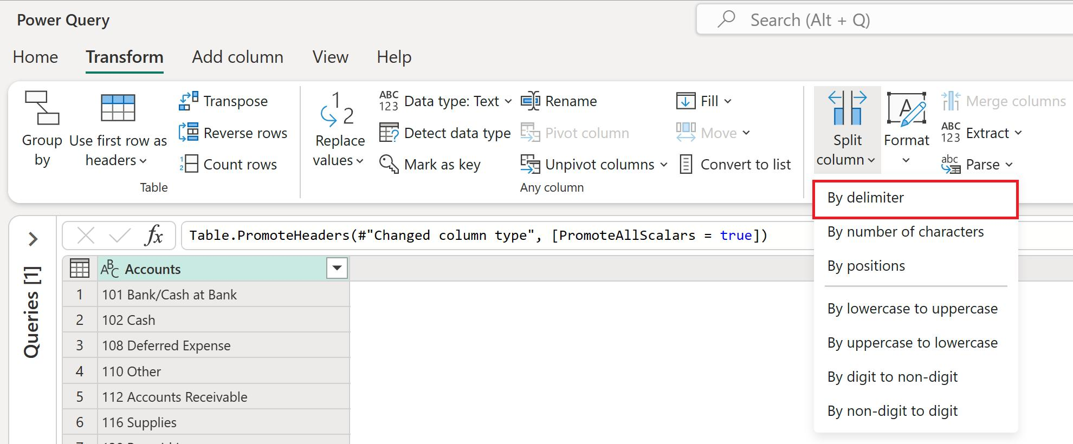
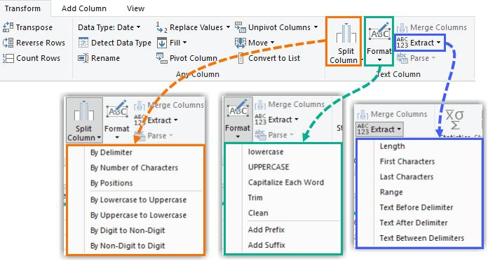
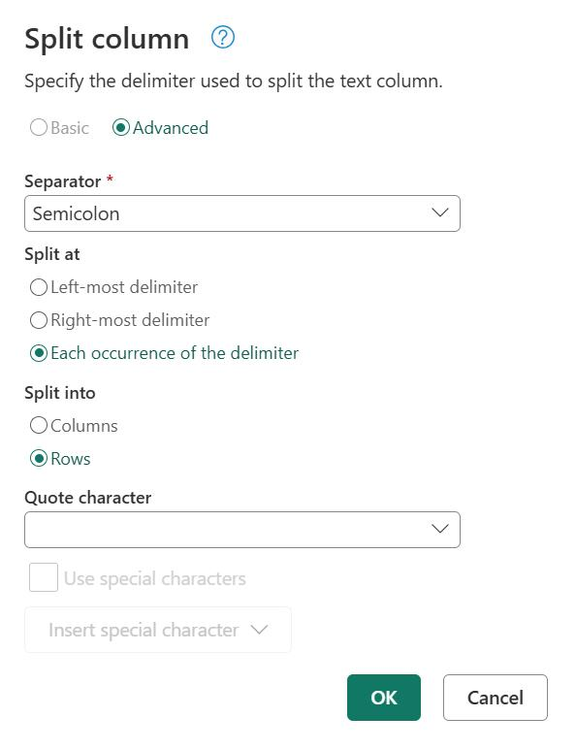
2. Merge Queries
Merge combines data from two tables using a common field (similar to SQL JOIN).
Example
Employee Table
EmpID | Name
101 | Amit
102 | Priya

Salary Table
EmpID | Salary
101 | 50000
102 | 60000

Result After Merge
EmpID | Name | Salary
101 | Amit | 50000
102 | Priya | 60000
Steps
- Load both tables into Power Query.
- Click Home → Merge Queries.
- Select first table.
- Select second table.
- Select common column (EmpID).
- Choose Join Type:
  - Left Outer
  - Right Outer
  - Inner Join
  - Full Outer
- Click OK.
- Expand merged column.
- Load data.
Image
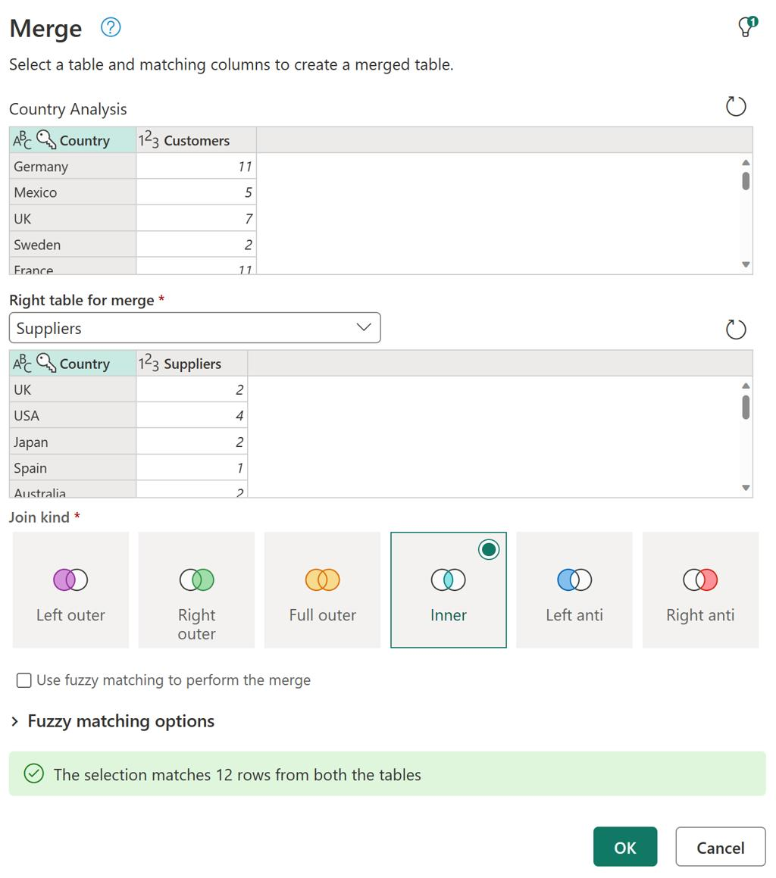
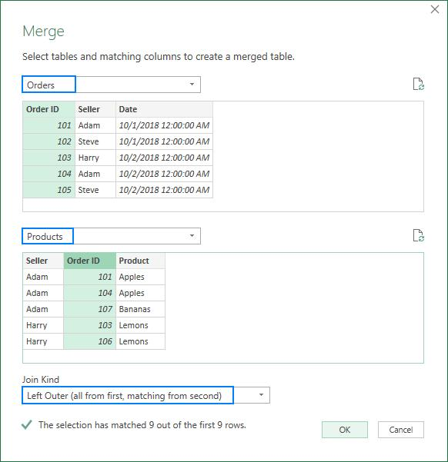
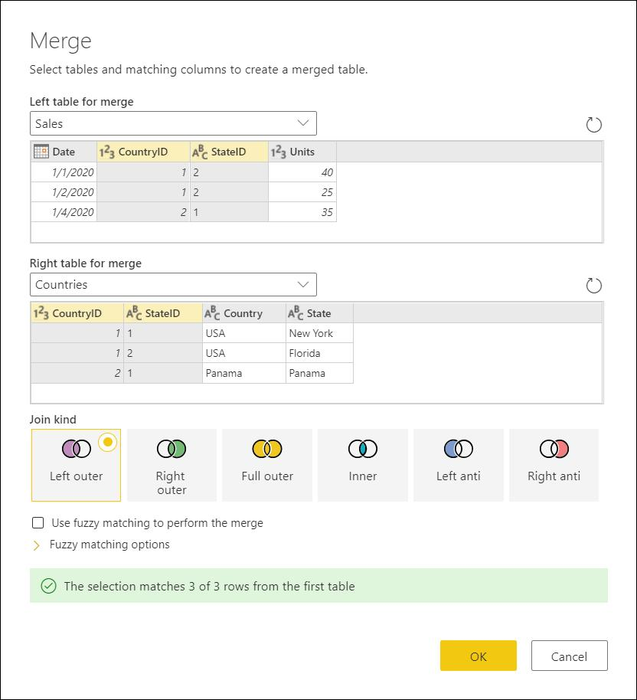

3. Append Queries
Append combines rows from multiple tables.
Example
January Sales
Month | Sales
Jan | 10000
Jan | 15000
February Sales
Month | Sales
Feb | 12000
Feb | 18000
After Append
Month | Sales
Jan | 10000
Jan | 15000
Feb | 12000
Feb | 18000
Steps
- Load multiple tables.
- Open Power Query Editor.
- Click Home → Append Queries.
- Select tables.
- Click OK.
- Verify combined rows.
- Load data.
Difference
Merge | Append
Combines columns | Combines rows
Uses common key | No key required
Similar to JOIN | Similar to UNION

4. Column Profiling
Column profiling helps understand data quality and structure.
Features
Column Quality
Shows:
- Valid values
- Errors
- Empty values
Column Distribution
Shows:
- Distinct values
- Unique values
- Frequency
Column Profile
Shows:
- Minimum value
- Maximum value
- Average
- Error count
Example
Sales
1000
2000
NULL
Error
Column Quality:
- Valid = 50%
- Empty = 25%
- Error = 25%
Steps
- Open Power Query Editor.
- Click View tab.
- Enable:
  - Column Quality
  - Column Distribution
  - Column Profile
- Review statistics.
Image
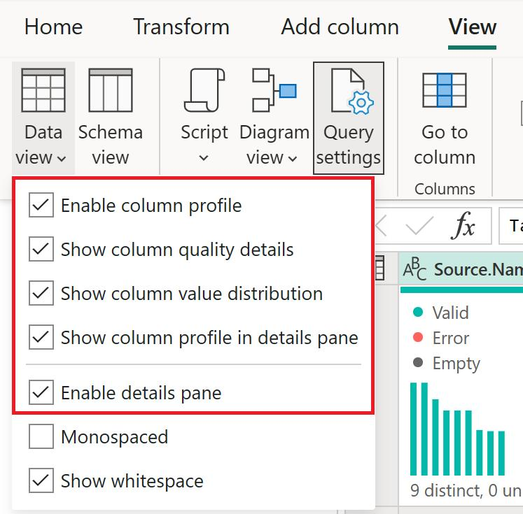
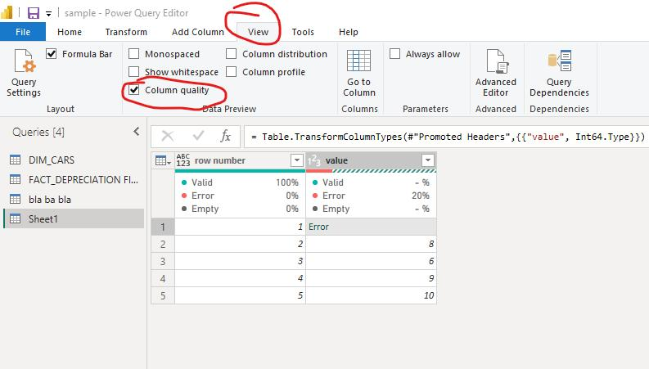
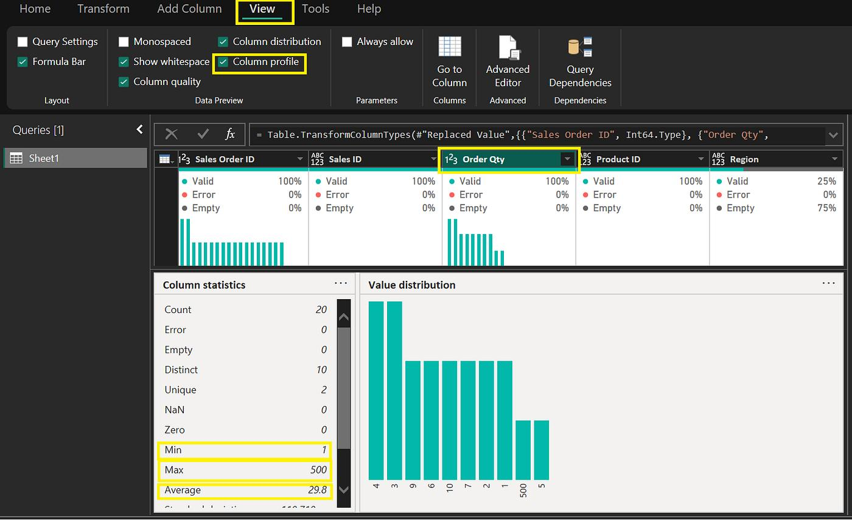

5. Parameters in Power Query
Parameters allow users to create dynamic and reusable queries.
Example
Create parameter:
Year = 2025
Use parameter to filter data dynamically.
Benefits
- Dynamic reports
- Easy maintenance
- User-controlled filtering
- Reusable queries
Steps
- Open Power Query Editor.
- Click Home → Manage Parameters → New Parameter.
- Enter:
  - Name
  - Type
  - Current Value
- Click OK.
- Use parameter in filters or calculations.
Example
Parameter:
SalesYear = 2025
Filter:
Year = SalesYear
Change parameter value to update results automatically.
Image
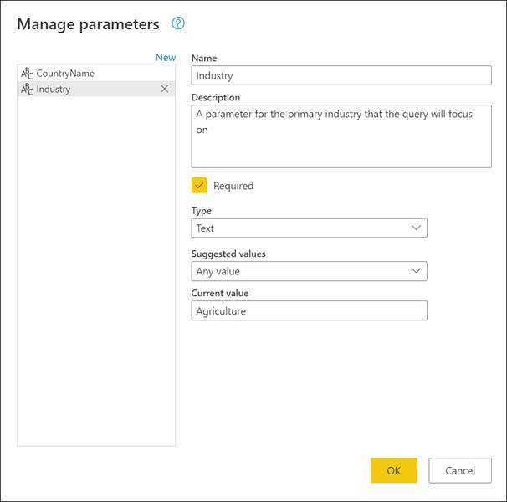
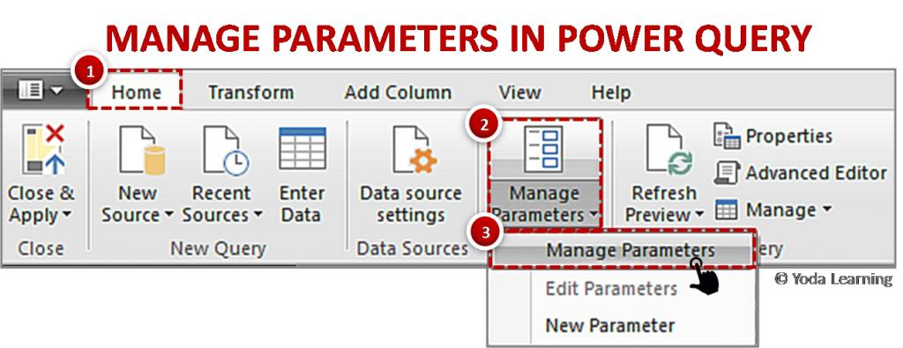
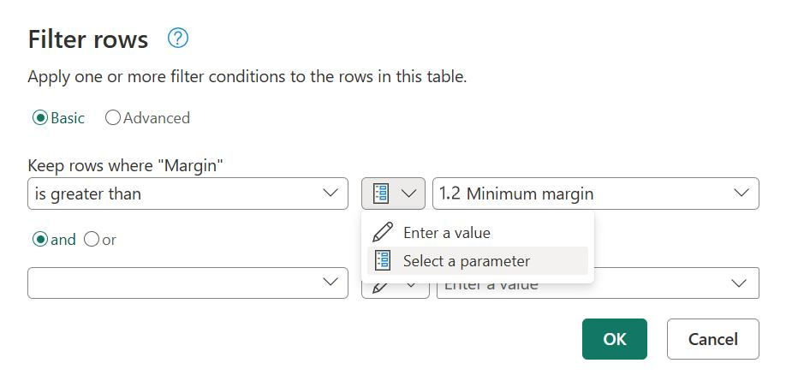

6. Handling Large Datasets
Power Query can process millions of records efficiently when optimized properly.
Best Practices
1. Filter Early
Apply filters before transformations.
Good
Filter → Transform → Load
Bad
Transform → Filter → Load

2. Remove Unnecessary Columns
Keep only required columns.
Before
ID | Name | Address | Phone | Salary
After
ID | Name | Salary

3. Use Correct Data Types
Assign:
- Number
- Date
- Text
Correctly to improve performance.

4. Disable Unnecessary Loads
Right-click query
Uncheck → Enable Load
for intermediate queries.

5. Use Query Folding
Allow Power Query to push operations back to the source database.
Examples:
- SQL Server
- Oracle
- MySQL
This reduces memory usage and improves speed.
Check Query Folding
- Right-click applied step.
- Select View Native Query.
- If enabled, query folding is working.
Image
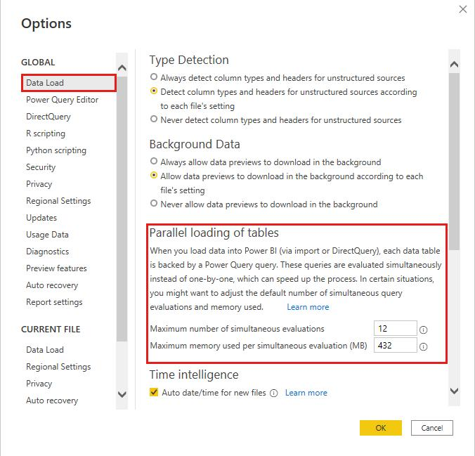
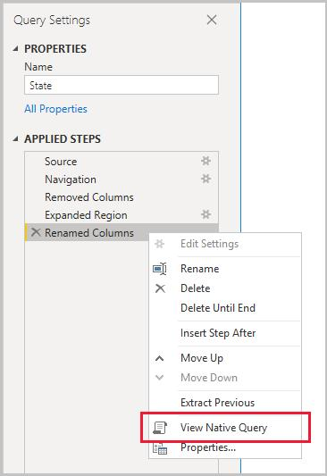
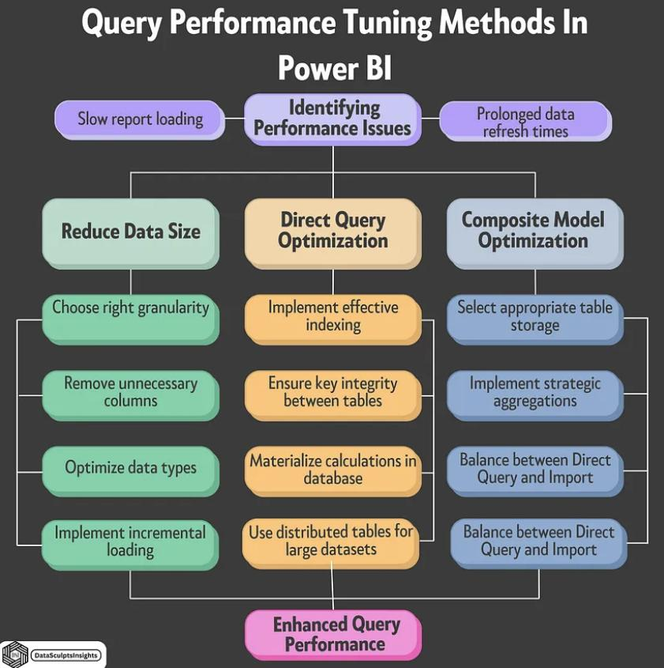
6

Interview Questions
Q1. What is ETL in Power Query?
Answer: ETL stands for Extract, Transform, and Load. Power Query extracts data from sources, transforms it, and loads it into Excel or Power BI.
Q2. What is the difference between Merge and Append?
Answer:
- Merge = Combine columns using a key.
- Append = Combine rows from multiple tables.
Q3. What is Column Profiling?
Answer: A feature that shows data quality, distribution, and statistics for each column.
Q4. Why use Parameters?
Answer: Parameters make queries dynamic and reusable without modifying query logic.
Q5. What is Query Folding?
Answer: Query Folding pushes transformations back to the source database, improving performance for large datasets.

